
Lab Report
Department: Department of Computer Science and Engineering
Course Title: Computer Networks Lab
Course Code: CSE0612314
Experiment No.: 01
Experiment Title: Introduction to Cisco Packet Tracer, Types of Network Topologies

Submitted to:
Teacher’s name: Trisha Sarkar
Designation: Lecturer
Department of CSE
UITS

Submitted by:
Student name: Badhon Kumar Roy
Student Id: 04324205101042
Section: 5A2
Semester: Autumn 2026
Batch: 56th
Date of Submission: 15 August, 2026
Laboratory Report
1. Experiment Number: 01
2. Experiment Title: Introduction to Cisco Packet Tracer, Types of Network Topologies

3. Objectives:
- To learn the basics of Cisco Packet Tracer.
- To understand how networking devices are connected in Packet Tracer.
- To learn the concepts of network topology.
- To identify different types of topologies.
- To design simple topologies and test connectivity in Packet Tracer.

4. Theoretical Background:
Cisco Packet Tracer is basically a simulator where we can build networks without needing real switches. We just drag and drop devices like PC’s, Switches, connect them with cables and see how everything works. It’s really useful for practicing before touching actual hardware. Along with that, we also learn network topology, which just means how devices are arranged and connected in a network. There are different types like Bus, Star, Ring, Mesh and Hybrid and each one has its own pros and cons. Knowing these basics helps a lot before moving to more advanced networking stuff later.

5. Tools and Software used:
- Cisco Packet Tracer,
- PC-PT,
- PT-Switch,
- Wires.

6. Network Topology:
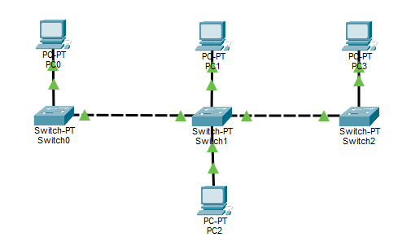
Figure 1.1: Bus Topology

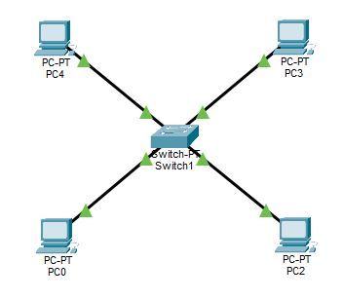

Figure 1.2: Star Topology

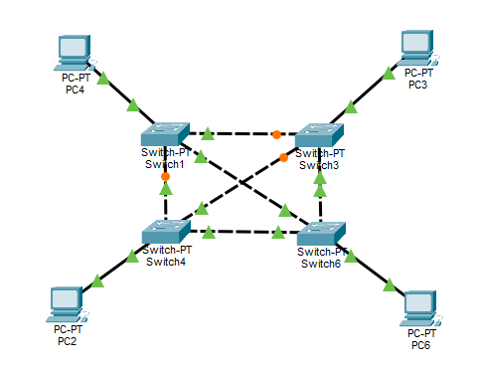
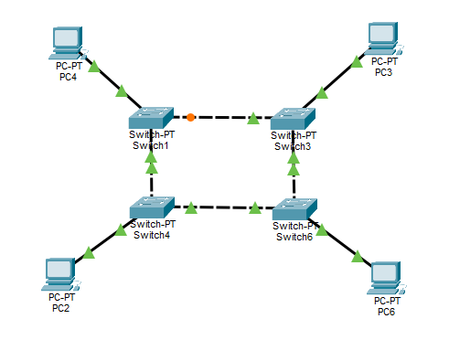
Figure 1.3: Ring Topology
Figure 1.4: Mesh Topology

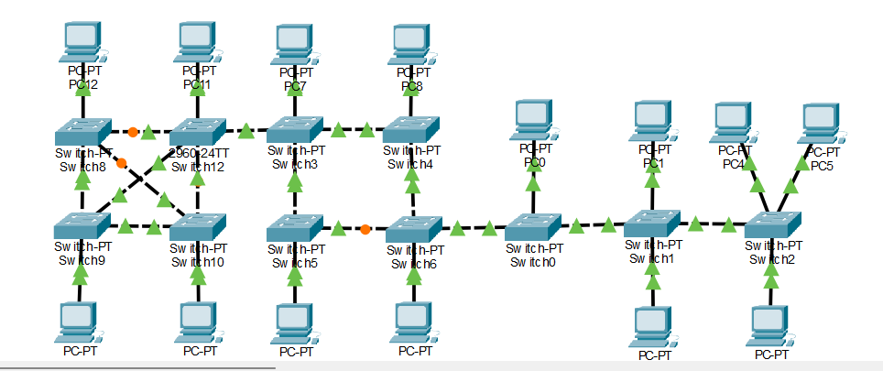
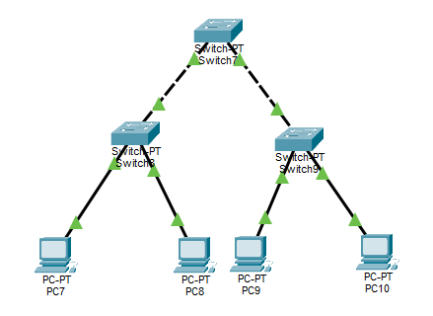
Figure 1.5: Tree Topology
Figure 1.6: Hybrid Topology

7. Methodology:
- At first, we installed the Cisco Packet Tracker and successfully setup it and opened it.
- Selected required devices like PC’s, Switches form the device panel and placed them on the workspace.
- Connected devices using appropriate cables based on the topology being built.
- Built a Bus topology by connecting all devices along a single common backbone cable.
- Built a Star topology by connecting all end devices individually to a central switch.
- Built a Ring topology by connecting each device to two neighbouring devices, forming a closed loop.
- Built a Mesh topology by interconnecting devices with multiple redundant links.
- Built a Tree topology by connecting multiple star networks through a central switch/router.
- Build a Hybrid topology by using Bus, Star, Ring, Mesh and tree topology.
- Took screenshots of each topology.

8. Output:
9. Conclusion:
This experiment gave a practical understanding of Cisco Packet Tracer and how different network topologies work. By building bus, star, ring, mesh, tree, and hybrid topologies, it became clear how device arrangement affects cost, reliability, and troubleshooting. Star and tree were easier to manage, mesh offered better reliability through redundancy, and hybrid showed how real networks combine designs to balance performance and cost. Overall, the experiment built a solid foundation in network design and hands-on use of a widely used simulation tool.

